6006 Dissertation (2024-2025 Semester A):
An Attempt on Transformer Realization
Name: WANG Haoyu ID: 59066216 Email: hwang845-c@my.cityu.edu.hk
Part I. Project Destination
Before midterm of semester A, we talked about the principles of Transformer. To summary, it is a huge natural language processing model applied all kinds of mathematic skills. By using the core technique called “Attention Mechanism”, which means to calculate the relations between one token and the others, it predicts the translated outcome of a sentence. The main goal of this project is to learn the mathematic mechanism of Transformer, try to realize the Transformer described in the paper, explore the properties of Transformer’s output, build further applications based on Transformer.
Part II. A Brief Introduction to Transformer
The illustration below is the sketch of Transformer, most of the layers included in it is shown in the picture.
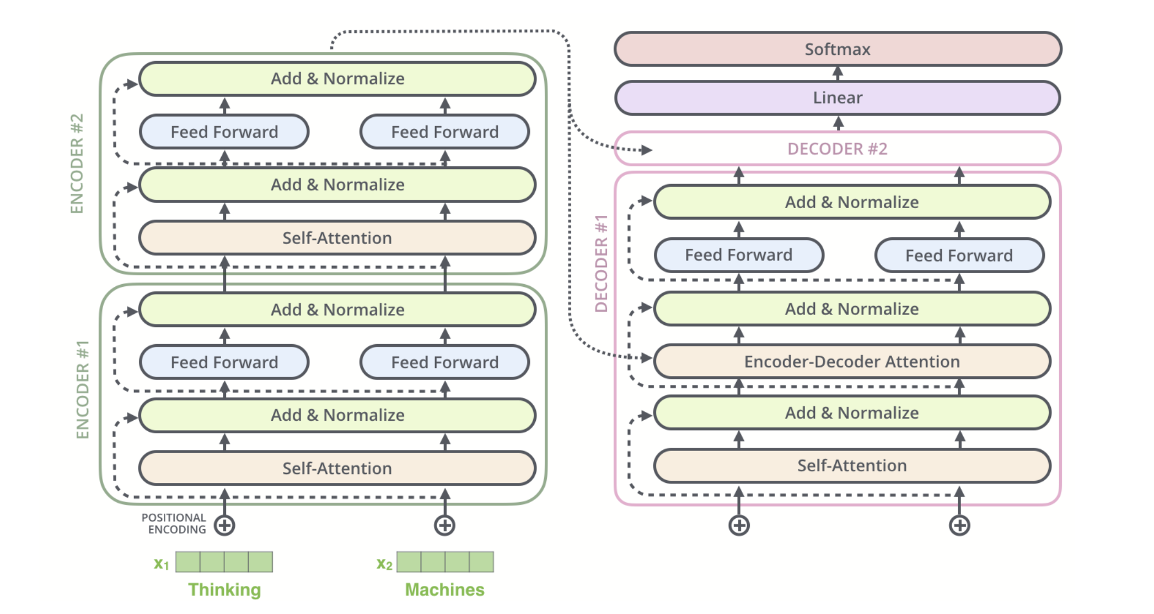
After tokenization, each token is embedded into a vector, add positional encoding, and treated as the input of the encoder.
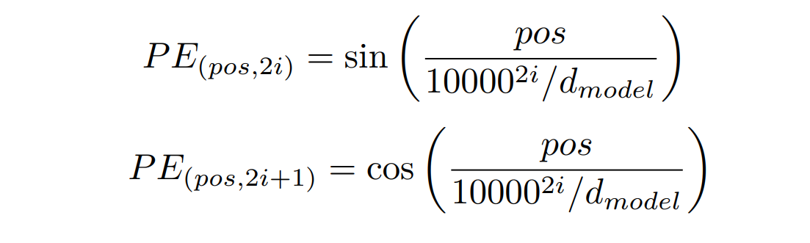
Then we calculate the Q, K, V matrix using weights
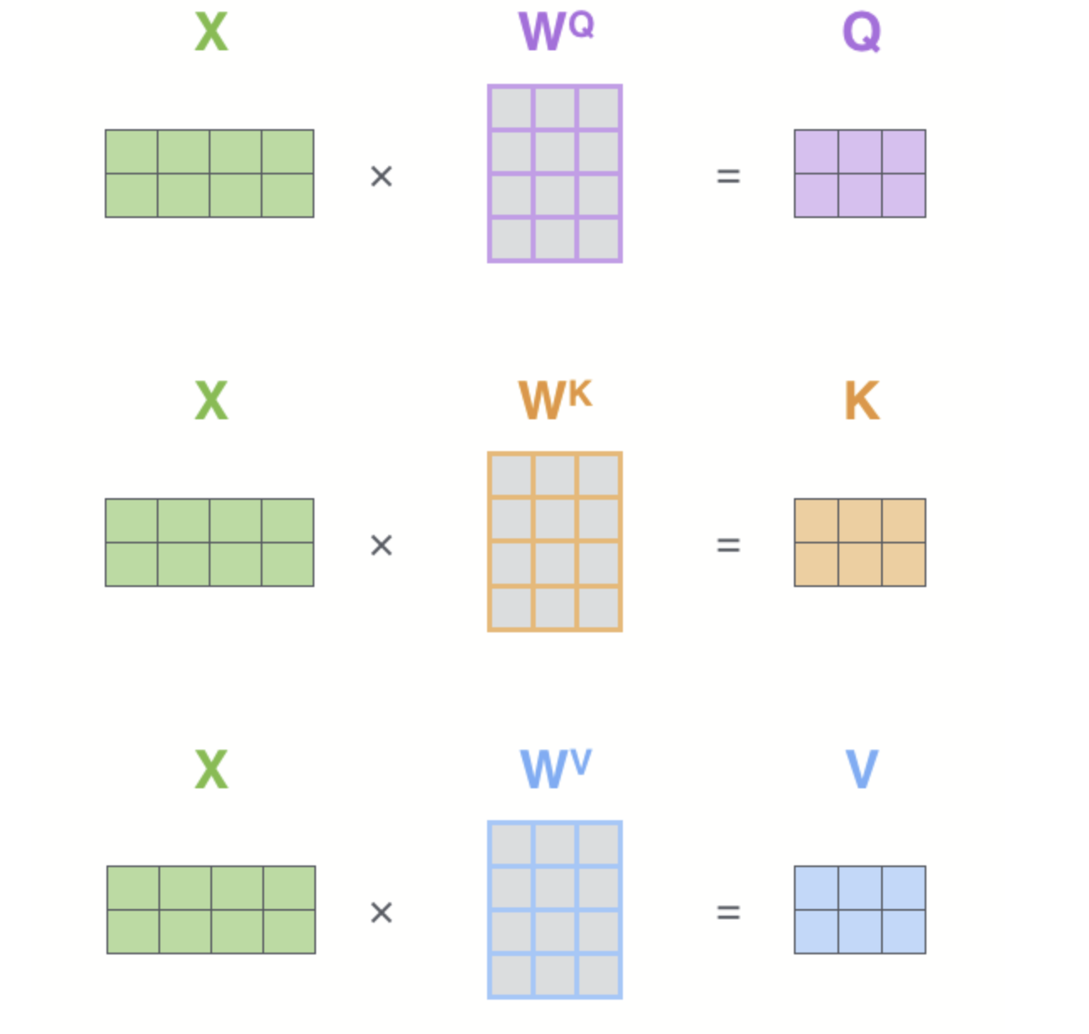
Then calculate the output of the self-attention layer.
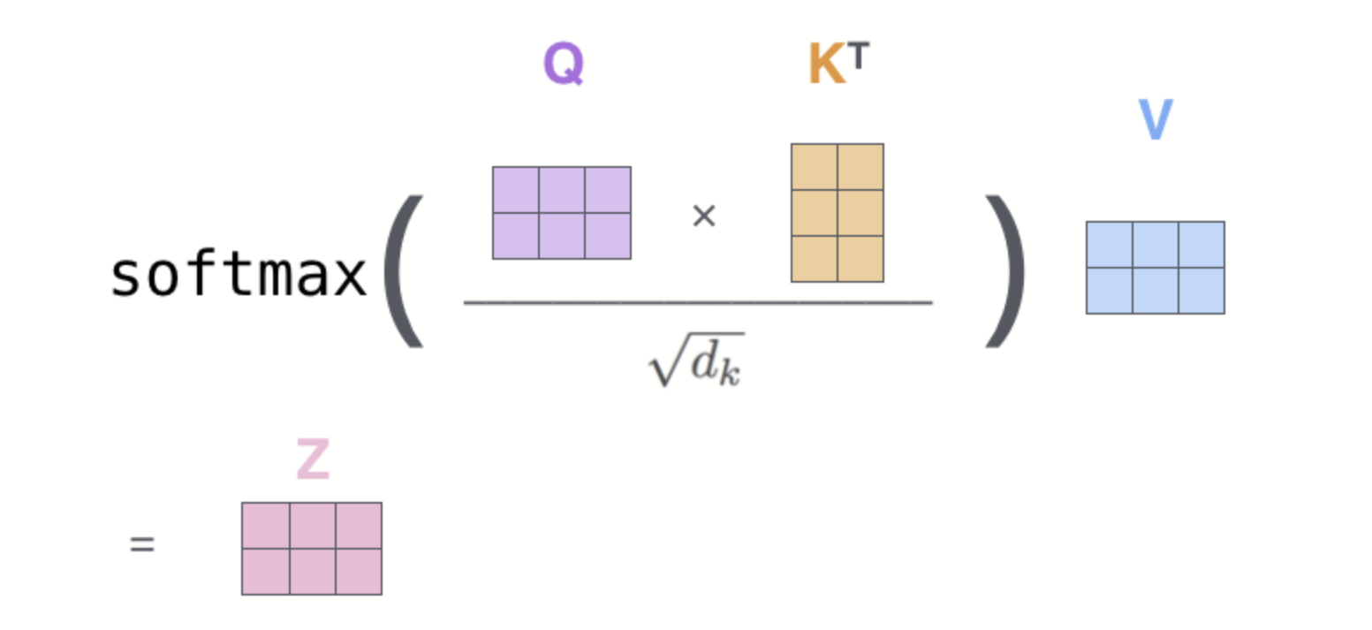
To get better result, we apply multiple heads, so the process may seem like this:
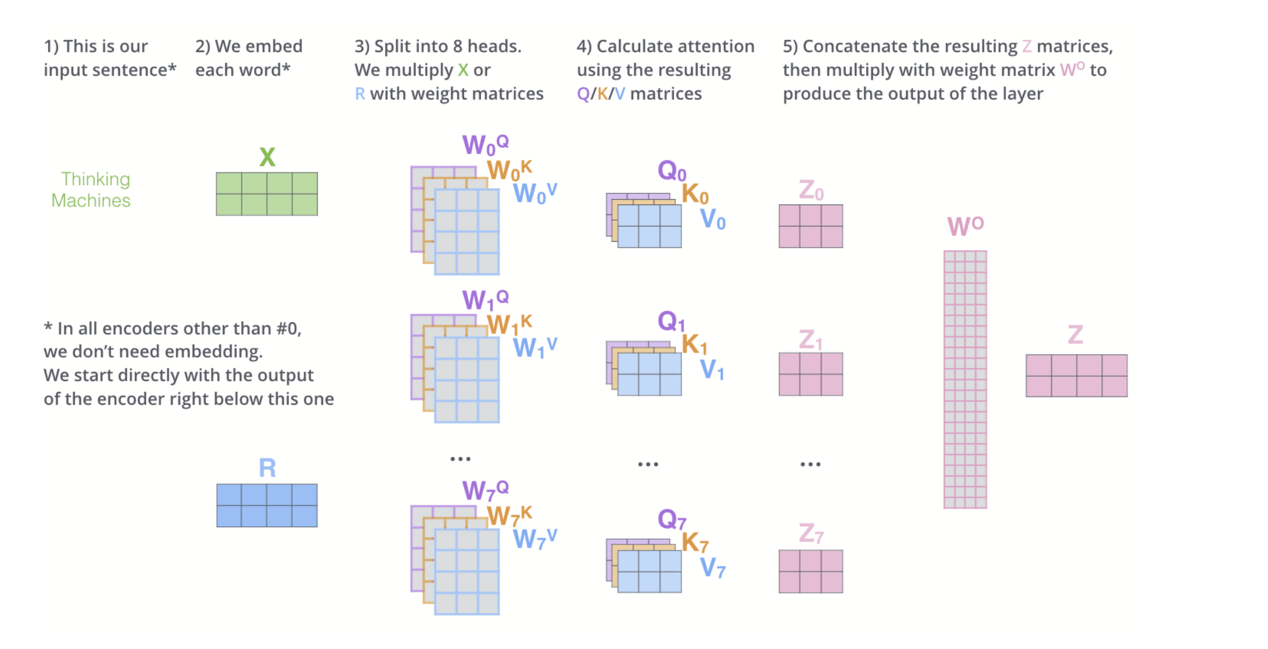
After feed the outputs to the paralleled Feed-forward Layer, we build an encoder block, the encoder blocks altogether form the encoder of the Transformer.
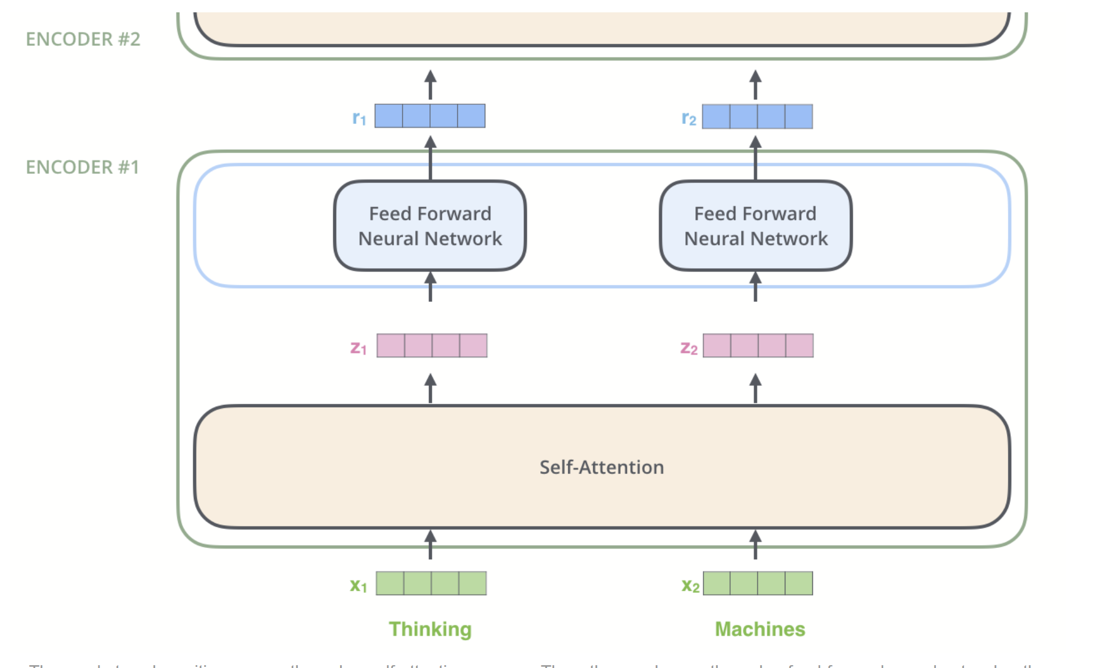
Similar to encoder, a decoder block consists of a self-attention layer, an encoder-decoder layer and a feed-forward layer.
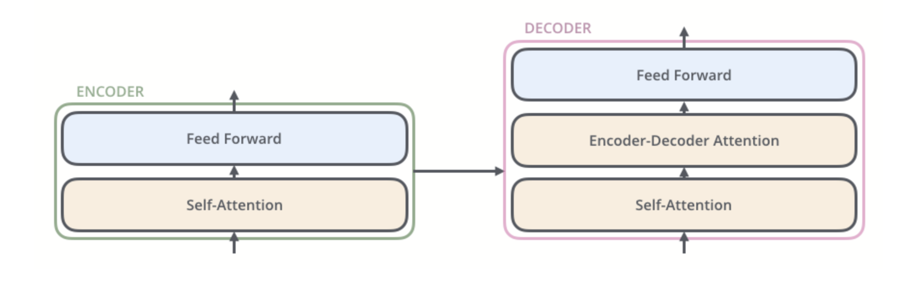
Part III. Research Progress
I have built a Transformer of translation so far, it aims at translating English into Italian. I have trained the model for 50 epochs and the result is pretty good, it can almost translate the sentence correctly. A flaw of the present model is there are some padding tokens appear in the outcome but it doesn’t affect understanding.
Part IV. Run the Code and Cautions
- First of all, because we use the dataset on Hugging face, which is a foreign website, and the host server in China, which cannot access the foreign website, we need to download the dataset to local first, and then upload the dataset to our host server. For this step, run NoOutWeb.py to download the dataset.
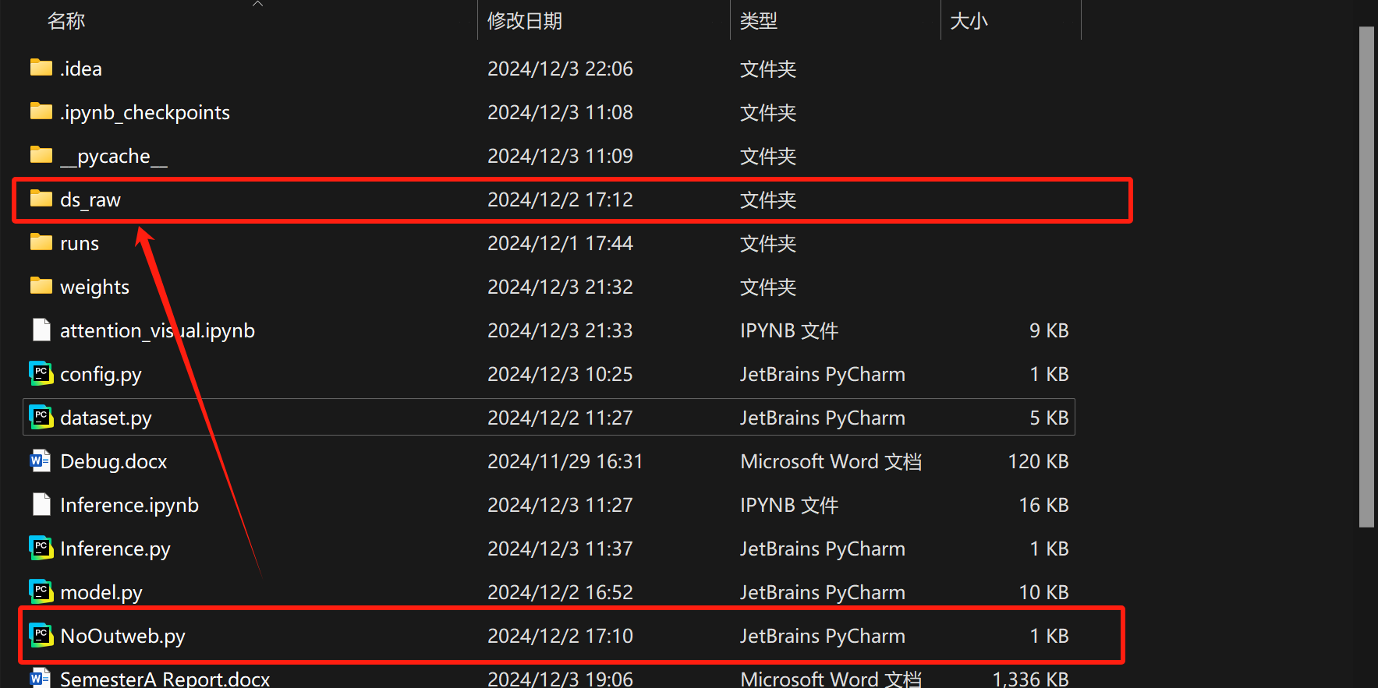
- When we first run the main code (train.py), you may find that the dictionaries of the tokenizers of both languages miss tokens: [SOS], [EOS], [PAD], [UNK]. But don’t worry, I didn’t find corresponding function in python to add these tokens to the dictionaries by code, so I manually add these tokens to the dictionaries of tokenizers in json file. You can use the tokenizers provided by me (tokenizer_en.json, tokenizer_it.json), or you can generate them by yourself and add these missing tokens to the dictionaries.
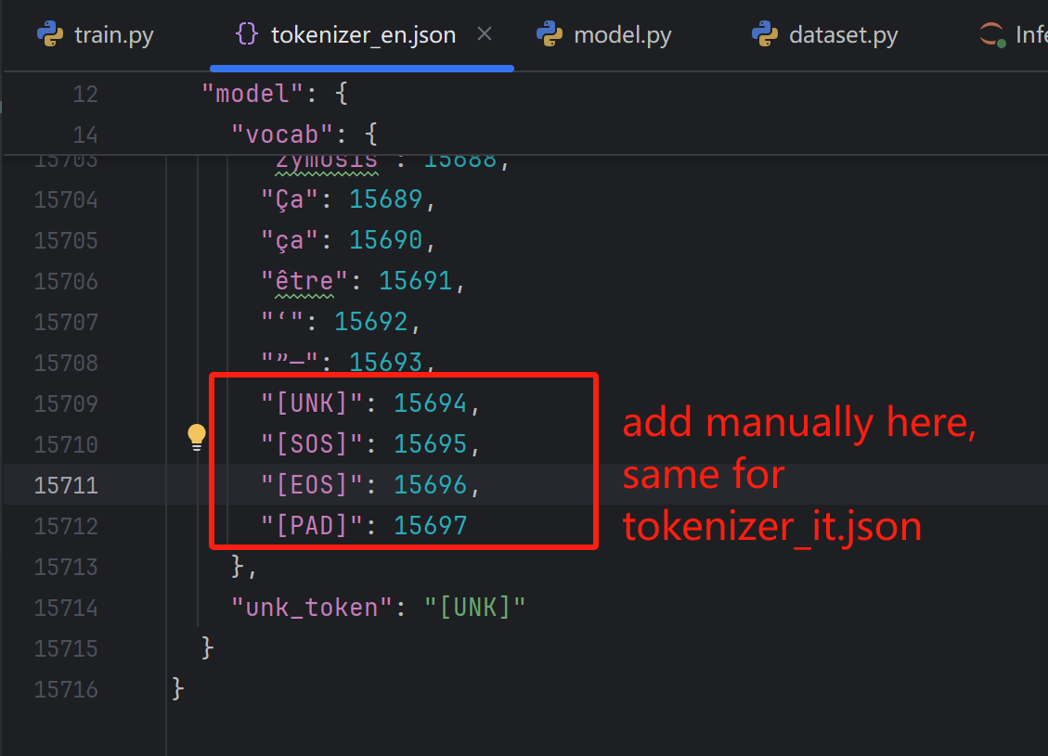
- Choose the Python Interpreter. There may be other ways to train the model, but I used ‘cuda’ device.
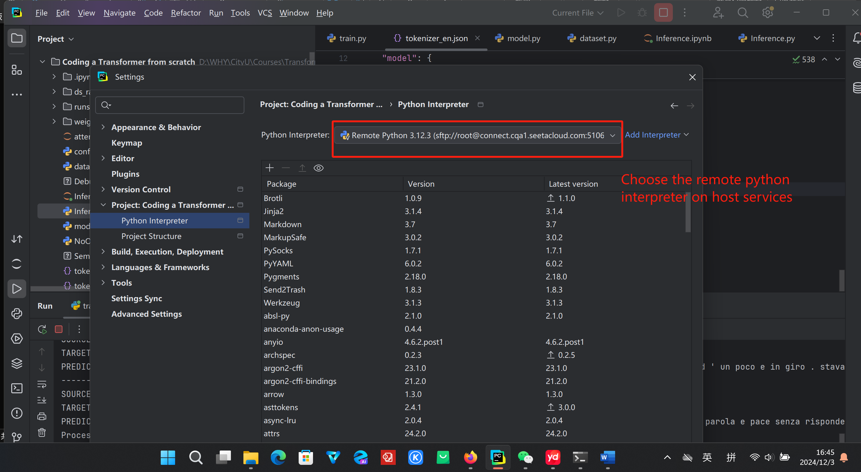
- Then run the “train.py”. You can see the progress of the training, there are also test translation at the end of the epoch.
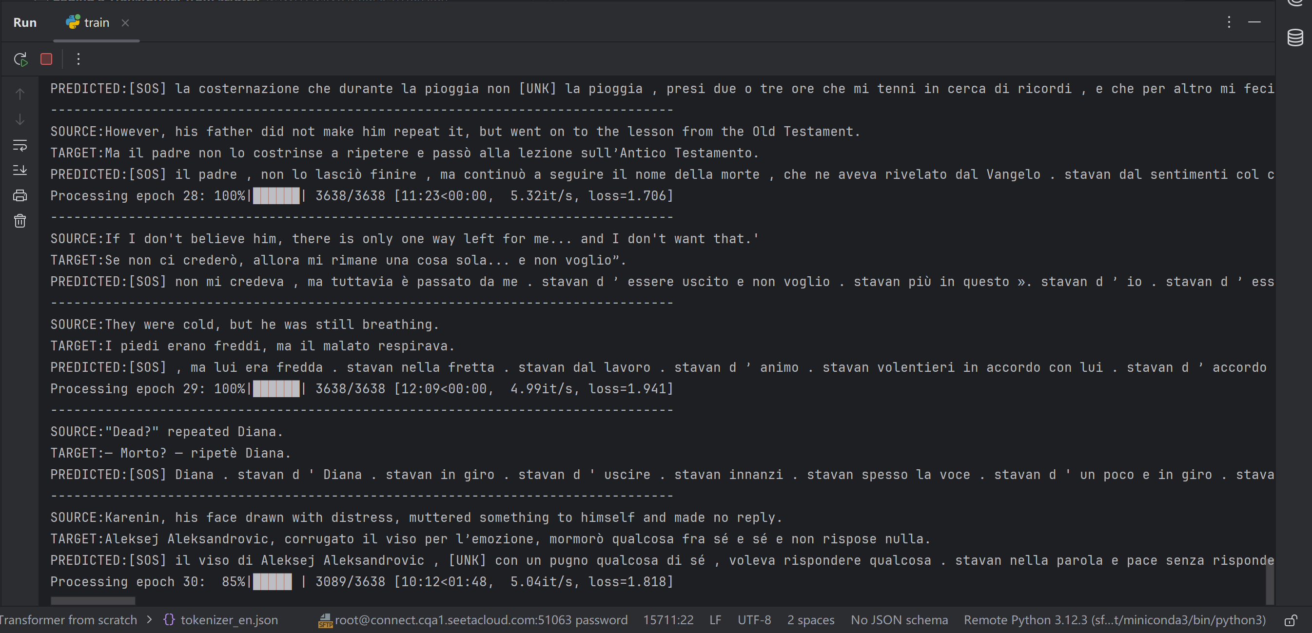
- After finishing the training progress, download the weights from host server. (Here we use Xftp8 to realize file transfer)
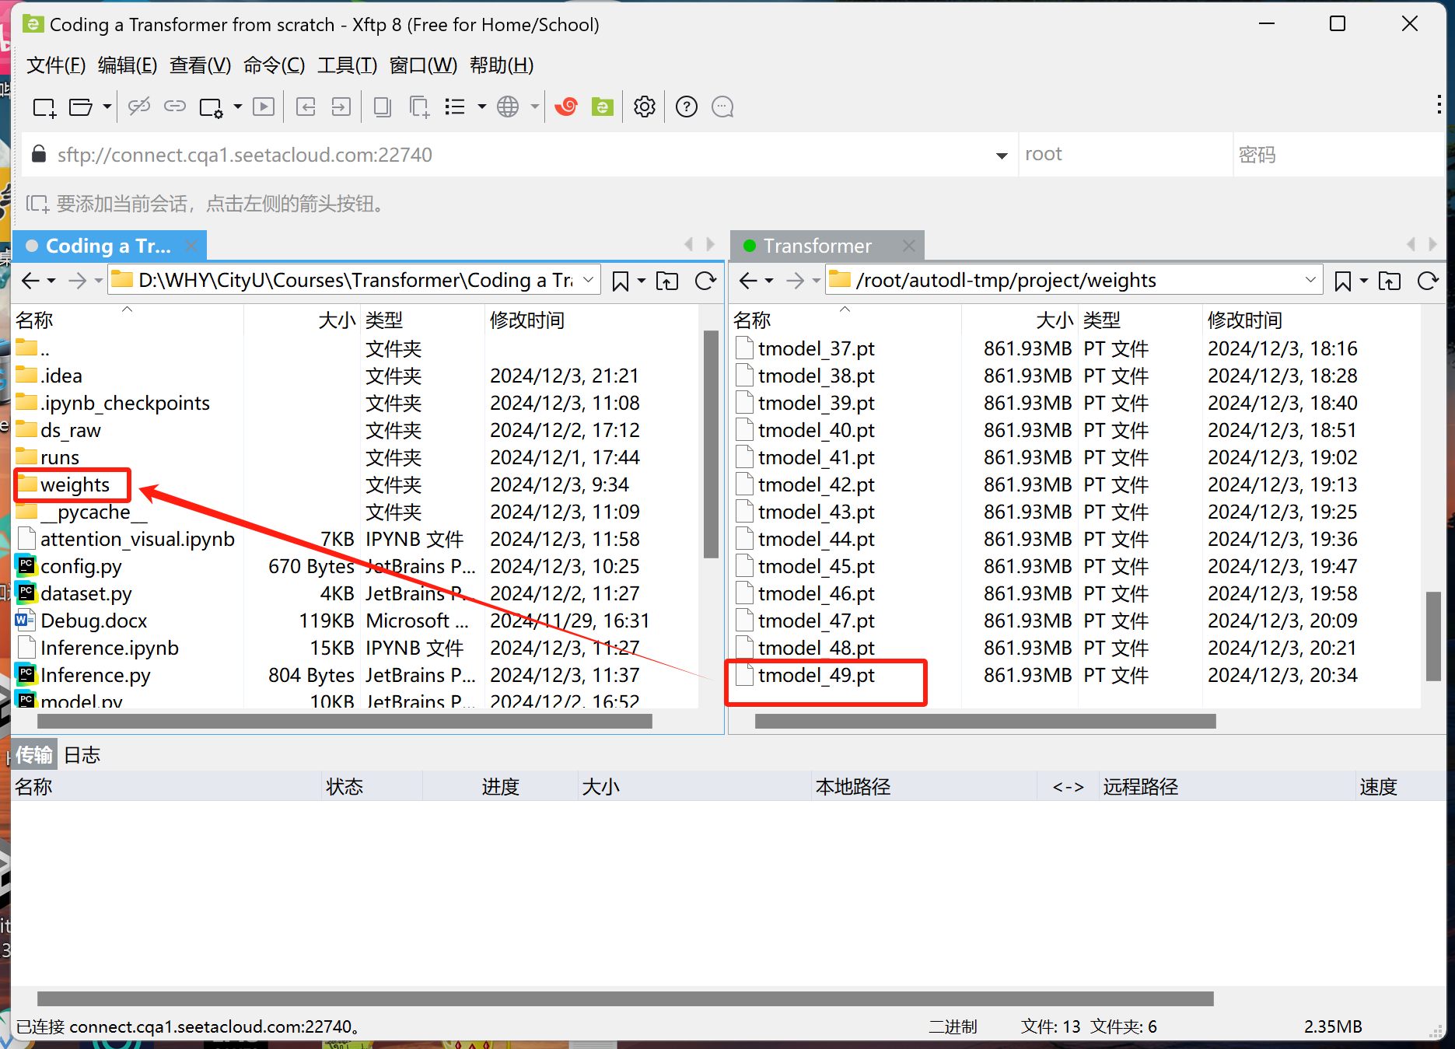
- Then run the validation via jupyter notbook. Gain output like below:
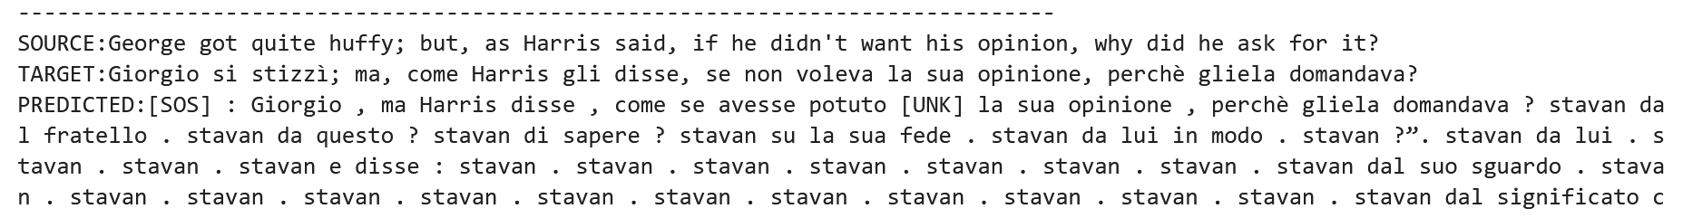
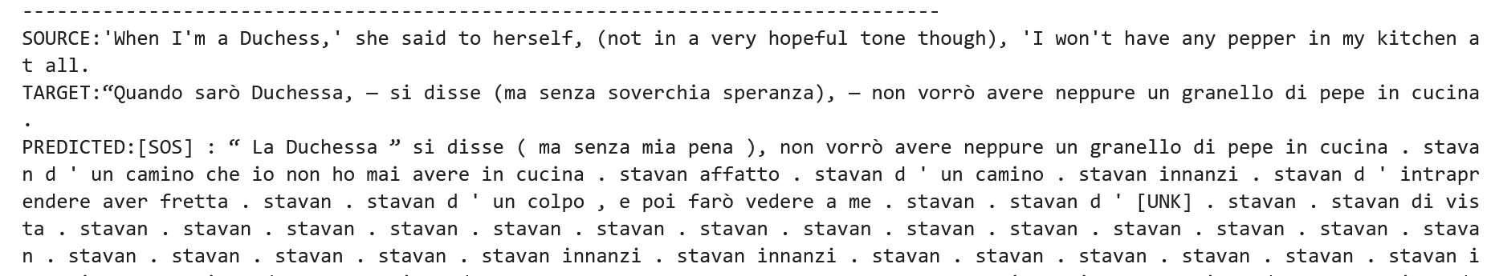
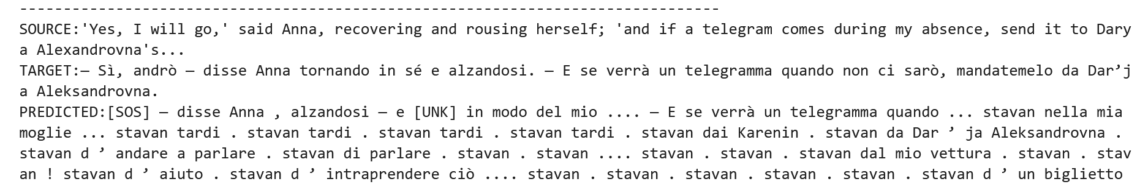
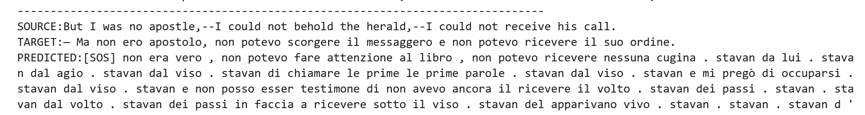
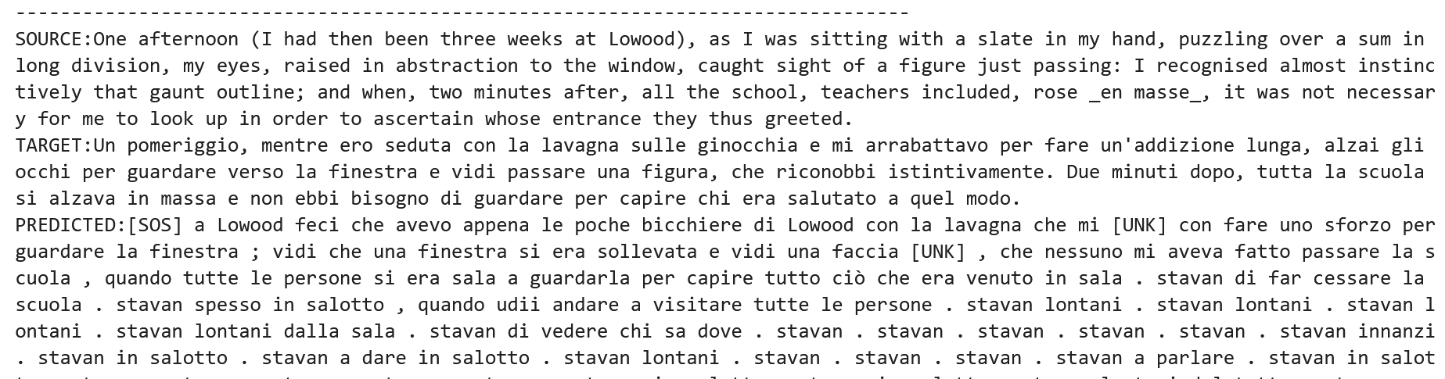
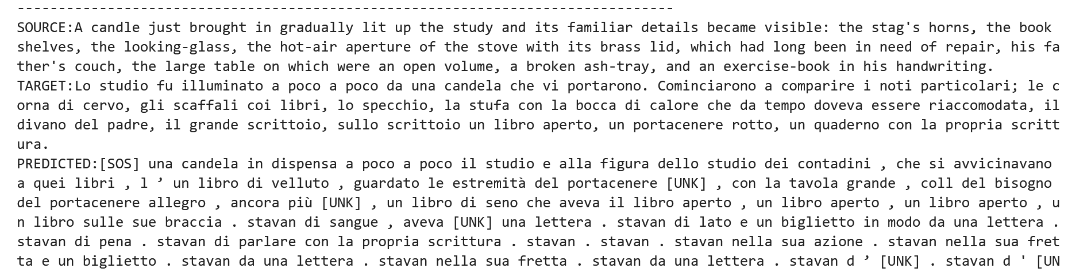
- You can also visualize the attention heat map by run the Attention Visualization.
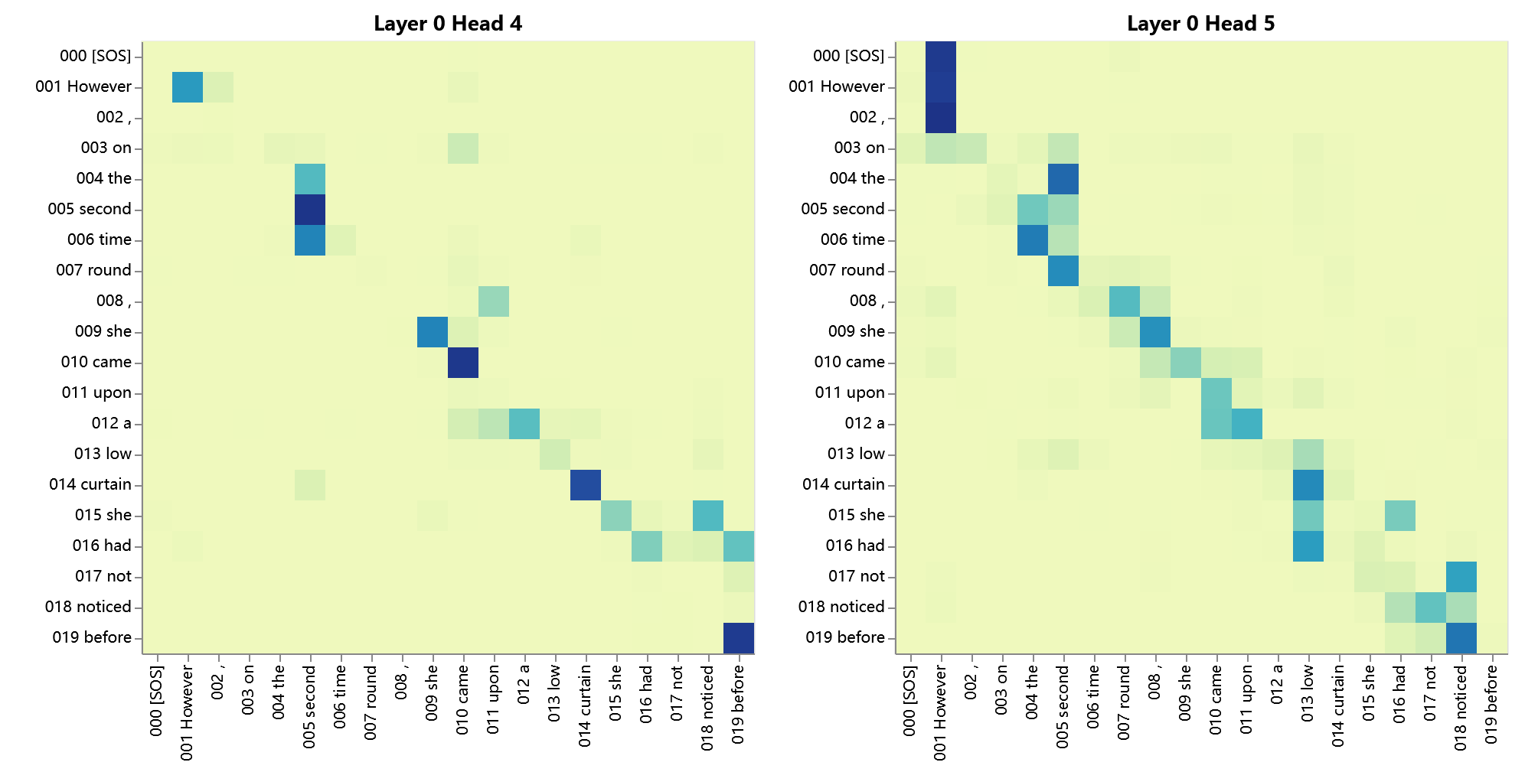
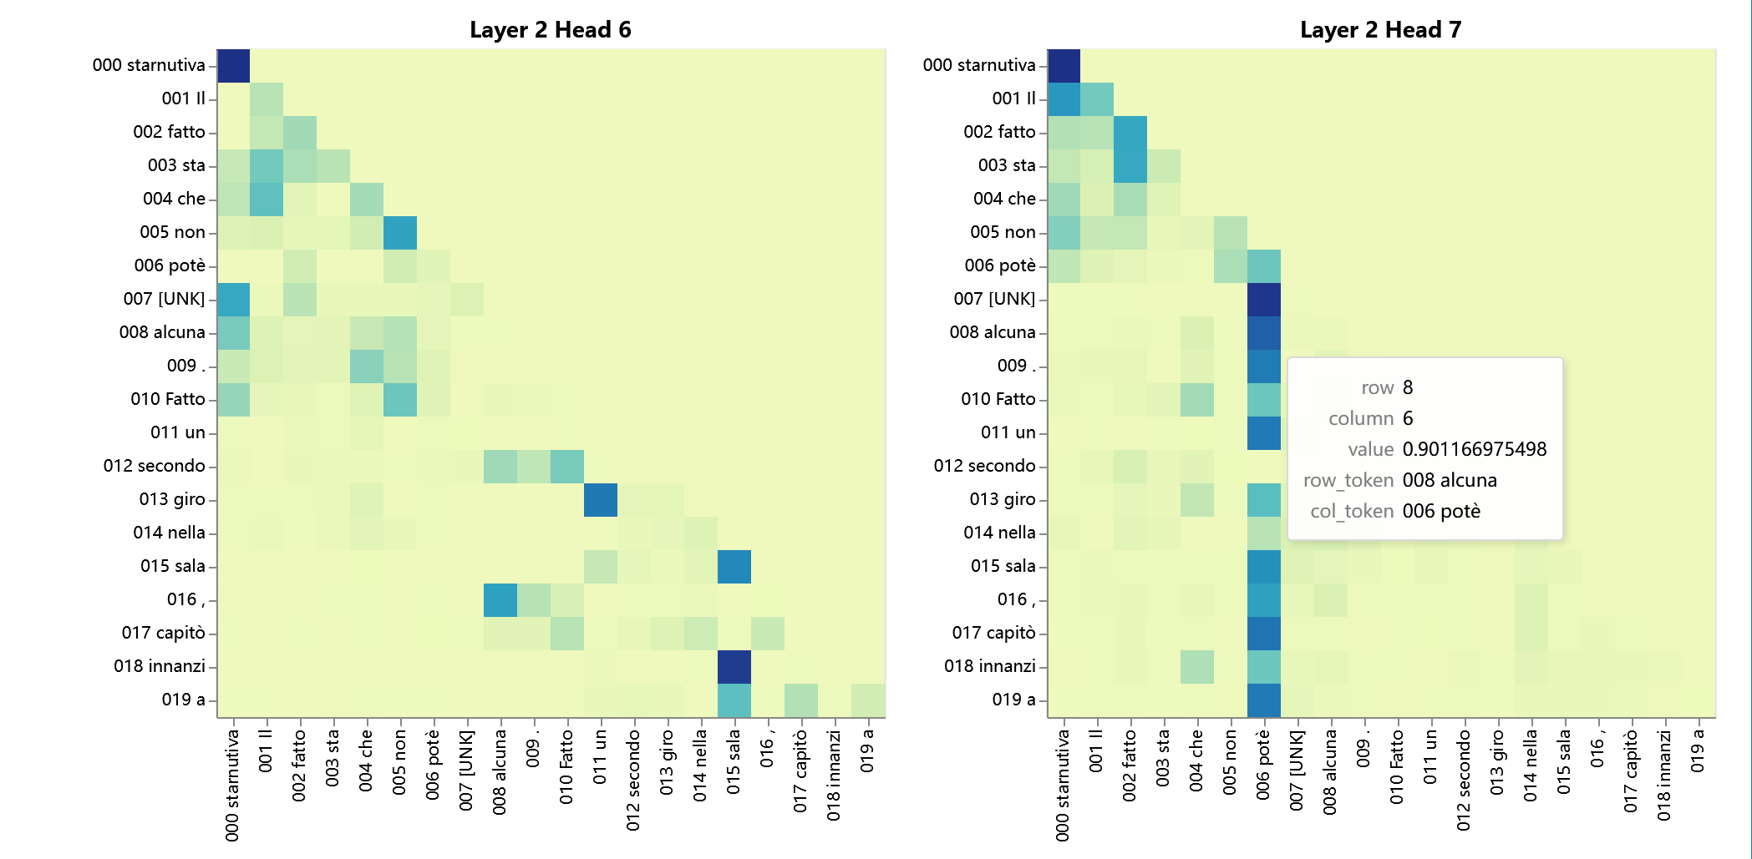

#Above is the application of my Transformer. There may be many problems generated while running the codes because of different environments and settings, so if you have any problems about the application, you can contact me via email.
Part V Future Prospect
A Transformer on translation between English and Italian has been built, but there are still some flaws of the model. After correcting these flaws, I want to talked about the properties of Transformer. For example, there are multiple heads of Transformer, “Is function of each head meaningful and credible?”, “Could the outputs of a token through all heads be the same?”.
After the exploration of these questions, I want to apply Transformer in some other scenes. For example, extend it to translations between other languages, and even to other categories such as sentiment analysis, semantic analysis, image identification and so on. There is no doubt that Transformer has that kind of potential to solve problems in lots of categories, but this requires to learn more about the Transformer and build models far more complicated. We can build the Transformer into a super powerful monster, but before that, there are still long roads for us to walk down.

